REPORT
1. INTRODUCTION
1.1 Project Overview
Project Title: Smart Sorting: Transfer Learning for Identifying Rotten Fruits and Vegetables
TeamID: LTVIP2026TMIDS68598
Team Members:
Team Leader : Jagadabi Vishnuvardhan Raju
Team member : Kothiralla Vani
Team member : N Sudeepthi
Team member : Sasi Chiramani
ProjectDescription:
This project is a machine learning–based web application designed to detect the freshness condition of fruits and vegetables. The system classifies input images into Healthy (Fresh) or Rotten categories. It helps reduce food waste, improve quality control, and assist consumers and vendors in making informed decisions.
1.2 Purpose
The purpose of this project is to:
- Detect freshness of fruits and vegetables automatically
- Reduce food wastage using early spoilage detection
- Assist farmers, vendors, and consumers
Demonstrate real-world application of Machine Learning & Computer Vision
2. IDEATION PHASE
Manual inspection of fruits and vegetables is time-consuming, inconsistent, and prone to errors. Spoiled produce often reaches consumers due to lack of automated quality assessment systems. Hence, an intelligent system is required to accurately identify fresh and rotten produce using image analysis.
2.2 Empathy Map Canvas
Users | Feel | Think | Do | Pain Points
Consumers | Concerned about food quality | “Is this safe to eat?” | Buy fruits & vegetables | Spoilage
Vendors | Worried about losses | “How to detect rotten items?” | Sell produce | Waste
Farmers | Need quality control | “Howto maintain freshness?” | Harvest & supply | Storage issues

2.3 Brainstorming
Possible solutions considered:
- Manual inspection
- Rule-based image checking
- Machine Learning-based image classification (Chosen)
Machine learning was selected for its accuracy, scalability, and adaptability.
3. REQUIREMENT ANALYSIS
3.1 Customer Journey Map
- User opens the web application
- Uploads fruit/vegetable image
- Image sent to ML model
- Model predicts freshness
- Result displayed with image

3.2 Solution Requirements
Functional Requirements
- Upload image
- Predict Fresh or Rotten
- Display result with image
Non-Functional Requirements
- Fast response time
- High accuracy
- User-friendly interface

3.3 Data Flow Diagram
User→WebInterface
WebInterface→FlaskServer
FlaskServerMLModel
MLModel→Prediction
Prediction → User Interface
3.4 Technology Stack
Frontend Layer
- HTML5
- CSS3
- Responsive design
- Dynamic result highlighting
Backend Layer
- Python Flask framework
- REST-based routing
- File upload handling
- Model inference
Machine Learning Layer
- Image preprocessing
- Feature extraction
- SVM classifier
- Model serialization using Pickle

4. PROJECT DESIGN
4.1 Problem–Solution Fit
The proposed system automates freshness detection, directly addressing food quality assessment challenges and reducing waste.
4.2 Proposed Solution
A Flask-based web application integrated with a trained ML model that classifies fruits and vegetables into Fresh or Rotten using image features.
4.3 Solution Architecture
User → Browser → Flask App → ML Model → Prediction → UI Result
5. PROJECT PLANNING & SCHEDULING
Phase | Duration
Dataset Collection | 1 Week
Model Training | 2 Weeks
UI Development | 1 Week
Backend Integration | 1 Week
Testing | 1 Week

6. FUNCTIONAL AND PERFORMANCE TESTING
- Model tested on multiple images
- Handles different fruits & vegetables
- Prediction time within seconds
7. RESULTS
The system correctly classifies images as:
- Fresh / Healthy
- Rotten / Spoiled
7.1 Output Screens
Home Page
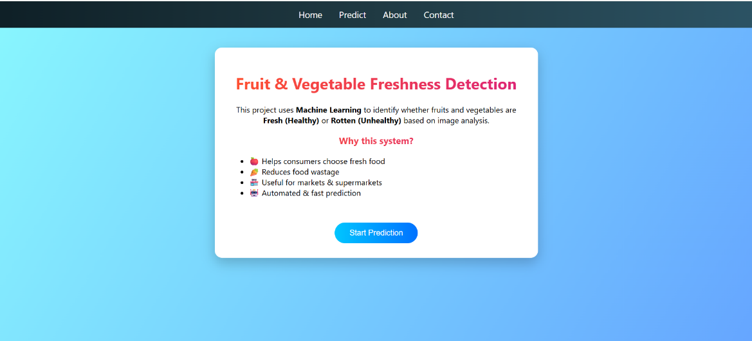
Contact Page
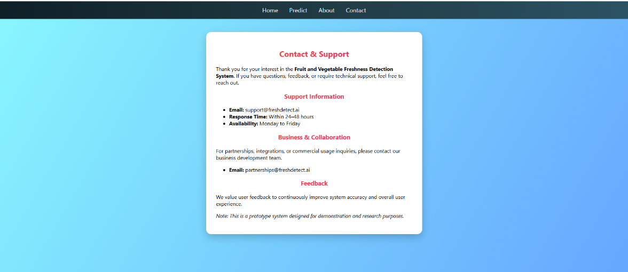
About Page
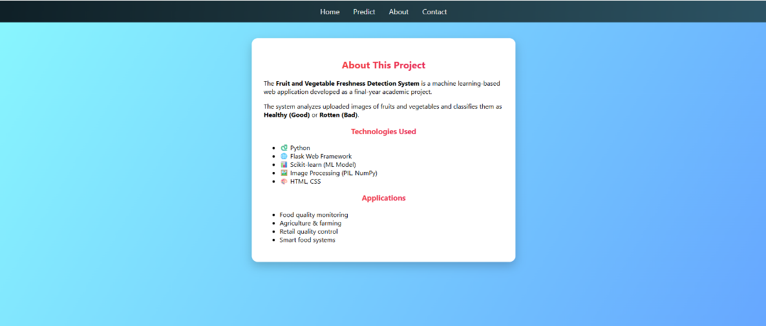
Image Upload Page
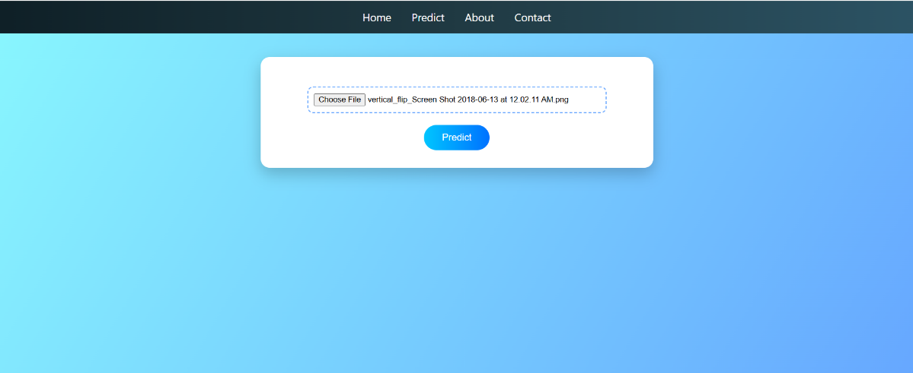
Result Page
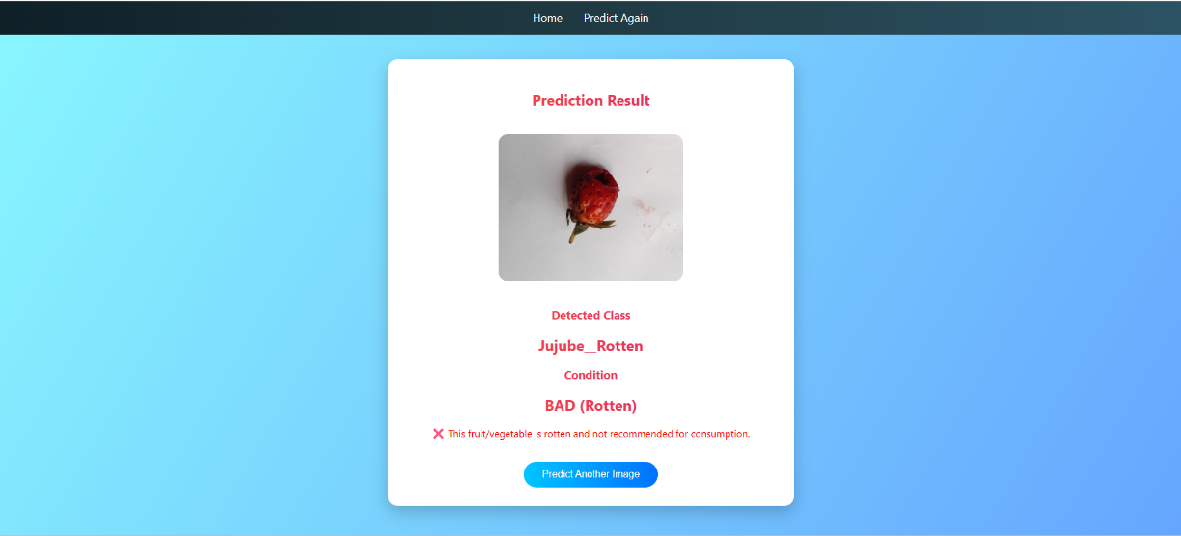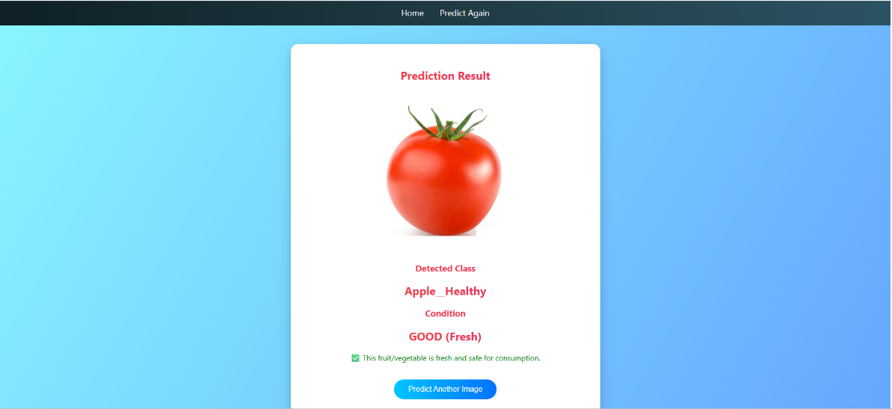
8. ADVANTAGES & DISADVANTAGES
Advantages
- Reduces food wastage
- Automated quality check
- Easy to use
- Accurate predictions
Disadvantages
- Depends on dataset quality
- Needs retraining for new produce types
9. CONCLUSION
The Fruit and Vegetable Freshness Detection system successfully demonstrates the application of machine learning in food quality assessment. It provides accurate predictions and can be extended for real-world agricultural and commercial use.
10. FUTURE SCOPE
- Deep learning (CNNs)
- Mobile application
- Real-time camera detection
- Cloud deployment
11. APPENDIX
Dataset:
Fruit & Vegetable Image Dataset
SourceCode:
Available in project folder
GitHubRepository:
(Your GitHub Link)

